Introduction

Efficiency and stability is a subset of how markets move, and this has been a fascinating question over the centuries. This paper reflects on three views on this analysis, where we find that each theory has merit.

The efficiency of any given financial market is most importantly seen as (and we will focus on) the rate at which new information is correctly assimilated into price within a market (price efficiency). The optimal use of capital (effective used for/or not for the betterment of society) is also a part of the efficiency definition (Allocational efficiency). Operational efficiency, to do with the minimisation of actual market costs, and informational efficiency, where all available information is ‘liquidly’ available to the public are other forms.

The definition of efficiency, as with stability is somewhat subjective depending on outlook. Stability might imply a polynomial expressions or straight line. Revolving around a stable average as in diagram 2, regarding US stock prices as an example, if one focusses on just a 20 year time horizon we see chaos. (1919-39 or 1990-2010). The mainstream label these periods as unstable, here it is where the common man losses most of his wealth most quickly. An unstable foreign exchange, would disrupt business and employee: Commodity price instability may cause cost push inflation: An instable sovereign bond market could start a domino of misfortune. Stability is generally seen as good and vice versa. Some have argued that instability is the engine of man’s creativity and evolution, or that “creative destruction” is necessary (not discussed).

In discussing the second section, global financial crisis analysis (GFCA), discussion is subdivided into the structural cause, social implications, the culprits, expected proof, interconnectedness of financial markets, causal/effects relationships, regulation, market and or political manipulation and the future.

THE EFFICIENT MARKET HYPOTHESIS (EMH)

The EMH asserts that stochastic markets are correct, quick and equilibrating while absorbing new information, absent exogenous shocks.

If a company were to report an unexpected trebling of profits, investors would translate this news so as to expect higher future dividends. This influx of demand would drive up share price, until in line with market yields and asset risk: Absorbing all available information, albeit from rumour, macro/micro economic changes to insider information etc. Market participants are rational expectants using structured mathematically based reasoning, and all available fundamental information in determining asset values.

EMH assumes high market efficiency (especially long-term), but not necessarily stablilty over the short-term. What seems to be unstable price action (crashes) might be due to exogenous shocks based on fundamental informational changes. They sub divide the theory into weak, semi and strong forms of efficiency to reflect what degree and speed of information absorption takes place.

If the strong form of the EMH is considered then conclusions follow that have been tested (but debated) repeatedly:
- If historical information is absorbed, we assume the future unknown, one being independent of the other, we would expect to see statistical randomness in the markets (A random walk).
- Either by technical or fundamental analysis participants cannot make returns that consistently beat the market, (beyond that given by chance, in a large enough sample, it is expected that a minor group would consistently beat the market by statistical chance alone). If markets were inefficient then active funds would exploit these opportunities.
- The price is based on fundamentals, rational mathematics and reasoning. With hindsight one should be able to observe, rational behaviour.
- Price gradients should be in proportion to the rate of change in information. Market crashes are impossible, absent a proportional change in information.

Extensive statistical research loosely confirms point 1 above. On point 2 we find evidence of “pre announcement drift” for example where prices efficiently move to fundamental correct valuations before financial statements are published. The work of Malkiel finds that over 20 years, active funds managers on average performed 2% worse than the index, with only 5 of 197 surviving firms from 1970 to 2001, beating the market by more than 2%. Malkiel and others support with point 4 above; major crashes “can be the rational response to small changes in interest rates” for example.

EMH supposes a neoclassical base, implying a structural approach to GFCA where mathematical modelling would be appropriate in understanding interconnected global causal effects in all markets. Cutting ties with an economically “sick” country should stop all contagion for example.

Information efficiency is a major factor in GFCA. Fluctuations would ensue if liquid, true and relevant information were blocked, distorted, or omitted. In the pre-crisis time period in 2008, the lay man and media was ignorant or uninformed in the main, and the hedge funds and surprisingly the rating agencies too weak in their inability to rate assets correctly. If asymmetric information is not known, it cannot be absorbed into price.

MINKSY

Minsky’s evaluation holds that instability is Inherent in financial markets due to the endogenous and dynamic mechanics of the market itself: “Instability itself is destabilising… capitalism is inherently flawed, being prone to booms, crisis and depressions”, however adding that capitalistic markets must possess these characteristics.

Minsky view on efficiency is wide, focusing on allocation of capital and equality for the masses: “It may also be maintained that capitalist societies are inequitable and inefficient”, with continual wealth redistribution.

Just after the last cyclical downturn, everyone in a nation is cautious. In good times well-meaning financial institutions and companies (or ‘Hedge’ units pervade), borrow conservatively when interest rates are low. Profit to interest cover is high, company gearing ratios are low. Banks only fund low risk projects. As the economy grows and many of the projects succeed, investment decisions are validated, the need to invest increases. The memory of the last downturn starts to diminish. Asset prices rise due to investment demand. As more loans are created (along with money supply), and invested into assets, so these prices rise. Speculative units increase in proportion (where cash flow from investments service the debt). The economy also grows. Investment projects are evaluated with less onerous guidelines. The banking sector shares the “euphoric optimism” and keeps lending and increasing money supply. The velocity of money might increase also. Gearing increases, but interest cover ratios decrease, making units susceptible. This turns more units into ‘Speculative’ or ‘Ponzi’ units (Units that need higher asset prices to service debts). Thereby “generating signals that induce an accelerating desire to invest and of financing the accelerating investment”

Crucially, liquidity decreases, while investment demand continues to increase at low interest rates. As per the simple classical model of interest rates, loanable funds supply decreases with liquidity, while investment demand for money continues to rise. The result is upward pressure on interest rates. The government’s standard monetary solution to inflation is the same.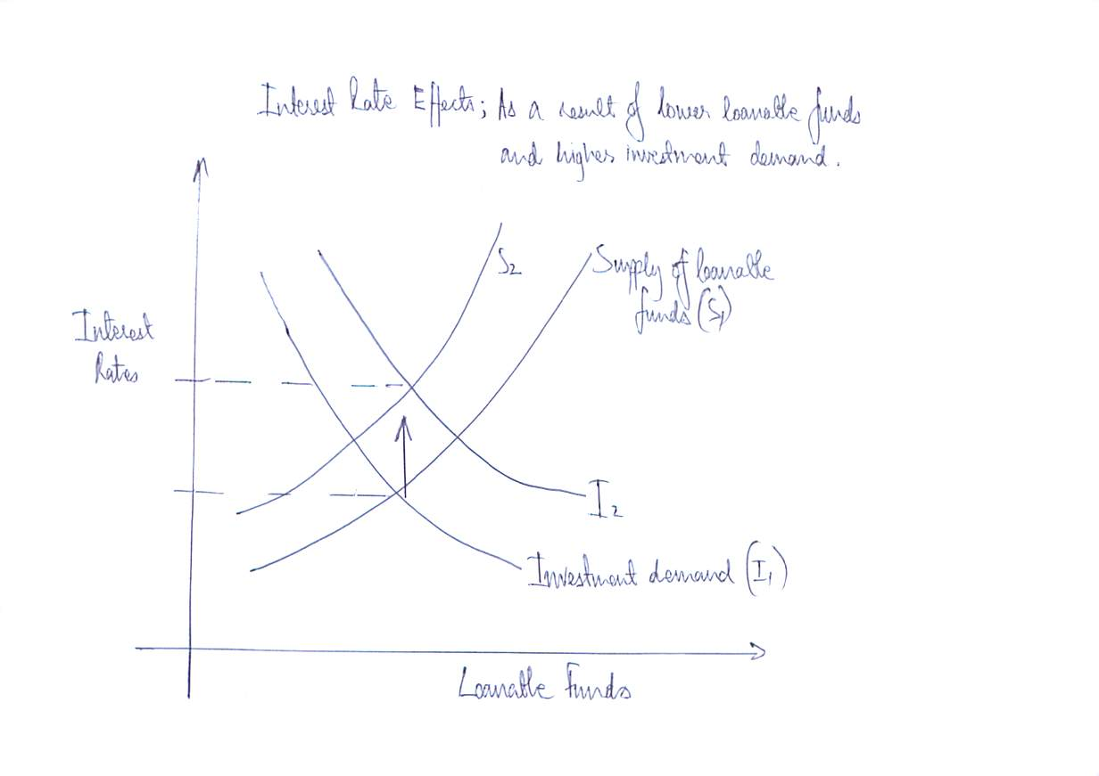 With a sudden increase in interest rates, everything begins to unwind including the money supply, where, asset prices, investment demand, and people liquidate their positions or go bankrupt. Asset prices fall, and sometimes violently into a fire sale or crisis. There are simply no buyers at the top due to their own micro circumstance.

Minsky evidence was involved, for example the progressively worsening shocks of 1966, 70, 74-75,80 ,82-83, 87, 2001 as endogenously caused, (perhaps in part due to deregulation) with another downward climax in 2007-8. Whereas neoclassicals (or EMH theorists) might “see unfavourable events as the work of evil outside forces”

Using fractional reserve banking and therefore money supply creation and destruction, company stewards of banks are incentivised to maximise shareholder value by maximising debts taken out; consequently “left unfettered they become the economy”. The GFC analyst must look at household and government debt and not to regard money as a mere lubricant as per ‘Says’ economic thinking.

Toward future prediction by way of GFCA, we find sustained low interest rates around the world partly in response to the last crisis. And long term bonds taken from the central banks to buy short term assets to hold down interest rates, in the form of QE. Global government debt has increased from 31(2008) to 56 (2015) Trillion Dollars since 2008. Divorced from any logical metric, “the can

has been kicked down the road” Minsky would predict the next round of instability at a future point where liquidity will dry again, absent an interest rate increase, but only toward short term cyclical rectification in any case. Fundamental instability will remain “upward”.

The 3 Minsky regular cures used in crisis where:
- Central Banks as the lenders of last resort
- The Government could increase it’s debt to stimulate demand
- The financial markets could have more onerous regulation.

Minsky provokes the analyst to look at total system mechanics (and overhaul) for a solution, with
focus on big government (size, spending and taxation), and to examine market power: “when the difficulties encountered by giant corporation and financial institutions are central to instability that plagues the economy, the very largest concentrations of private power should, in the interest of efficiency as well as stability, be reduced”

Inconceivably, Noam Chomski (5), others eludes to a hidden agenda of the political or ruling class in GFCA. The debt lever, is merely an instrument to maintain class divide, redistributing wealth on a timely basis to perpetuate servitude, toiling and culling of the weaker common man. Minsky’s cyclical observations seem to fit, albeit the ultimate cause is natural not conspired according to Minsky.

While the biggest economy pays other countries in US dollars, while at the same time being engaged in the Minsky QE cure, thereby devaluing the payment made, might have more ominous consequences. The work of the insider, Jim Rickards, via currency wars supports this view.

Behavioural Finance

Behaviourist believe that markets can be highly unstable, inefficient, certainly in the short term where prices become divorced from fundamentals, leading to a possible compromise in allocational efficiency.

It assigns movements in prices, efficiency and stability to human psychology, more specifically propagated stories, feedback loops, herd mentality and emotion. Mathematical logic is acknowledged but is regarded to be just a part of behavioural reasoning. The 1929 (or other) crash, would simple be the result of elaborate positive stories being set, believed and propagated, until “irrational exuberance” were to take hold. Successful investors would be copied, and the herd mentality would ensue, on the way up and down. An example might include the decade long farmland price bubble fuelled by a story about overpopulation, and starvation worries, in the USA in the 1970’s, or tulip mania in the 1700’s in Europe.

Intuitively even institutions and government can be broken down into people in any market place setting price. Behaviourist led by Robert Shiller, do not go against logic in their choice to fully understand these individuals, or understand the blocks that make up the whole.

A wealth of studies have shown that individuals tend to be biased in decision making, relying on emotional factors more so and often simply copying the majority. Recent Ponzi schemes can be flagged as further evidence Shiller notably points to several circumstances in company valuations where prices have clearly deviated from fundamentals, confirming that markets are not rationally driven at all, as per his famous diagram 2.

GFCA here would put much more weight on the workings of human behaviour and the precipitating factors in understanding the crisis.

The role of regulation in GFCA is highlighted, in order to protect us from ourselves, toward the proper allocation of capital, and for the people in an economy to share equally in asset devaluations. Shiller notes that there are “few forces to counteract” our bad behaviour”, and to help, “monetary should lean against bubbles”

Diagram 2
From Efficient Markets to Theory to Behavioural Finance. (Page 86). The Journal of Economic Perspective. By Prof. RJ Shiller

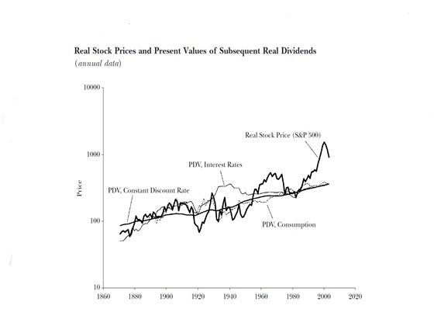

GFCA might consider manipulation. To think that that market makers will not be tempted to profit and collude while privileged to view demand and supply is extremely naïve. Richard Ney in his extensive works, and champion of the common man warned that ‘manipulation was as old as the hills’. Insiders have perfected the play on fear and greed, making ‘dumb money’ sell while the insiders built up stock and then buy from the same as a result of a media circus creating exuberance at the top. Although behaviourists observe the phenomena, they attach blame to defects in individual behaviour, but one step on and we may find the hidden villains at play.

Conclusion

An Impartial observer might suggest the EMH explains what should be, behaviourist best explain what is, and Minsky better explains the why. Time horizons seem to separate the theories. In the long term price is pulled back to fundamentalsand stability albeit with shorter term volatility, instability and inefficiency (Fig 2). The subjective “short term” in this context can last decades however.

The theories confirm that GFCA is complex and vast. We have not mentioned the different personalities of the countless financial markets and as they may differ around the world for example.

Each theory is unique however and has quite rightly endured. Rather like the analysis of the complex universe using several different wave lengths, looking at the same object, they all have insight to offer.

Financial markets include for the purpose of analysis here, the Stock, Money, Bond, Derivative, Commodity, Property and Foreign Exchange markets, around the world.
As per the work of Joseph Schumpeter,
Present Value of any financial instrument = Discounted Future Cash Flows. Many derivatives of the formulae exist. For stocks most commonly: PV=Expected future dividends/Discount factor
As per Fama, E.F (1970) Efficient Capital Markets, a review of theory and empirical work, Journal of Finance 383-416M Weak form of EMH, where all historic information is absorbed. The Semi Strong EMH, where all historic and present information is absorbed. And the strong form of EMH, where, including the prior two forms all privately held information is also absorbed.
Except for list number 3, they do not guarantee that price is in line with fundamentals, and therefore stable.
EG: Brealey R.A(1970) The distribution & Independence of successive rates of returns from the British Equity Markets, Journal of Business Finance.
Ball. R & Brown. P (1968) An empirical investigation of Income accounting numbers, Journal of Accounting research 159-78, Autumn
Malkiel, Burton G.1995.”Returns in investing in mutual funds 1971 to 1991. Journal of Finance June 50:2 pp549-72
The Financial Crisis and the Regulation of Credit Rating Agencies: A European Banking Perspective Siegfried Utzig , January 26, 2010, ADBI Working Paper No. 188
An “economy in which debt financed ownership of capital assets, and the extent to which such debt financing can be carried is market determined”
P6, Stabilising an unstable economy
P5, Stabilising an unstable economy
http://www.economist.com/content/global_debt_clock, The Econmists Global Debt Clock
Or “Fake it until you make it”, is now the common saying. From mainstream economists, such as Max Kieser, Prominent Economist, Journalist and Presenter, June 2015
H, Minsky, Stabilising an Unstable Economy
P10, Stabilising an instable econonmy
For example the work of William Still, “The Money Masters” 1996 or the partial rise of the Zietgiest Movement, led by Peter Joseph
Jim Rickards, The death of money,(2014) and Currency Wars (2012)
A term coined by Alan Greenspan, head of the USA Federal Reserve
As an example: Human Feedback loops might be observable by way of momentum in stock prices. As found by Jagedeesh and Titman (1993), that continued to beat the market using this approach in International, currency and Commodity markets.
The jailing of Bernard Madoff, (Feb 2009), after the collapse of his $50 Billion Ponzi fund. This is viewed by the behaviourists as a propagated story about wonderful returns, where in fact the fund was empty.
For Example, Sanju Basu (1977), Firms with high PE ratios tend to underperform.
P210, Irrational Exuberance, (book list 2)
Examples include; Libor rigging (2012), £14.5 in total fines , Mis-selling Insurance products while hedging themselves 2013, Bank compensation approx. 1 Billion. Foreign exchange rigging, 2014, (£2.6 Billion Fine)
Richard Ney, The Wall Street Gang (1975), among other literature. I respected Investment insider.
As per the work on fundamentals by Prof. Benjamin Graham for example.
Bibliography - S.Keen, Debunking Economics, Finance and Economic Breakdown (p 243-257), First Edition, 2007, Finance and Economic Breakdown, P243-258. - Robert J. Shiller, Irrational Exuberance, Second Edition Revised,2000, Efficient Markets, Random walks and Bubbles, p177-195 - Samuels, Wilkes, Brayshaw, Management of Company Finance, 6th Edition, 1997, Stock Market Efficiency, p385-427. - Kishtainy, Abbot, Farnon, et. The Economics Book, 1st edition, 2012 - Noam Chompski, How the world works, (2012) - Richard Ney, The Wall Street Gang (1974) Academic Journals - Evans, Trevor (2009) Money and Finance Today, Global Finance and Social Europe. Edward Elgar - Shiller, Robert J. 2003. From efficient markets theory to behavioral finance. Journal of Economic Perspectives. - Malkiel, Burton G 2003. The efficient market hypothesis and its critics. Journal of Economic Perspectives. 17, - Minsky, H, 1985. The Financial Instability Hypothesis: A Restatement. Post Keynesian Economic Theory. A Challenge to Neo Classical Economics Videos - Hubris: why economists failed to predict the crisis and how to avoid the next one, (June 2001, Professor Lord Desai, Professor Charles Goodhart, Stephen King. London School of Economics. - Prof. Steve Keen: Instability in Financial Markets 3/5, (14th April 2012), New Economic Thinking - Prof. Steve Keen: UK Chartered Financial Advisors Society talk: Why the global economy is stagnating (June 2015) - Prof. R. Shiller: Irrational Exuberance: as relevant as ever, London School of Economics - Crash Course on Hyman Minsky, (June 2010) L. Randall Wray, New Economic Thinking

